“Come Let Us Reason Together!”

ACTS Chapter 17

~ Let us learn three ways to reason for salvation:
> #1 - (v1-9) Let’s Reason from the Scriptures!
> #2 - (v10-15) Let’s Reason in the Scriptures!
> #3 - (v16-34) Come Let Us Reason Together!

> (v1-9) Let’s Reason from the Scriptures!
(v2) The word reason means- to try to persuade someone by argument. A motive or cause or justification of something, a fact put forward as this.

- Paul’s argument was twofold:
#1- To reason from the Scriptures how the Christ (Messiah) had to suffer & rise again.
#2- To reason from the Scriptures that Jesus is the Christ (Messiah).
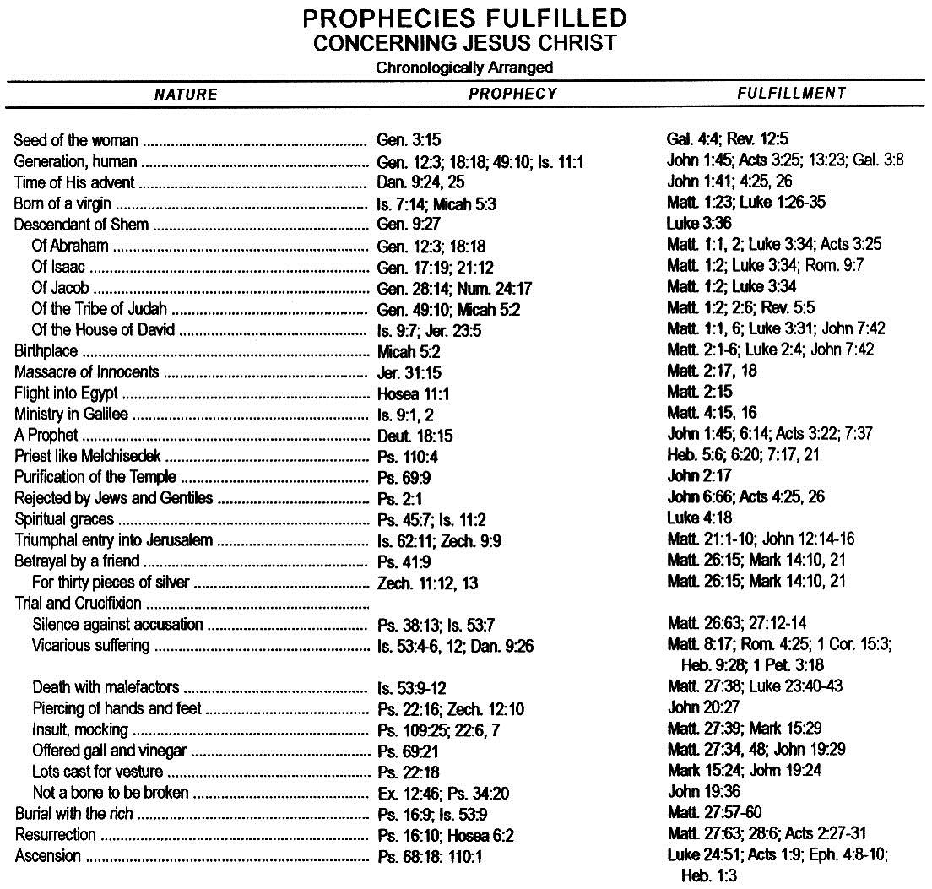
- Here’s a prophecy to think about: Daniel said the Messiah would appear 173,880 days when the commandment would be given for the Jews to return from Babylon to rebuild and restore Jerusalem (ref. Daniel Ch. 9).

- This command was given to Nehemiah on March 14th 445 B.C. (Nehemiah Ch. 2) and 173,880 days later brings us to April 6th 32 A.D. This is the day when Jesus rode into Jerusalem and the people laid down palm branches in front of Him and cried out “Hosanna, Hosanna, blessed is He who comes in the name of the Lord!” (ref. John 12:13) (Daniel also said that after this event the Messiah would be cut off, meaning crucified).

(v5-9) Insight on being envious - a feeling of discontent aroused by someone else’s possessions, position, or influence.

- Observe the vicious works of envy:
(1) Envy can gather a “mob;”
(2) Envy causes an “uproar;”
(3) Envy “attacks;”
(4) Envy drags down the “innocent;”
(5) Envy cries out “lies!”

- Remember, what Pilate observed when Jesus was brought to trial, for he knew that the chief priests had delivered him for envy.

- James speaks boldly about envy in James 3:14-17 - But if you have bitter envy and self-seeking in your hearts, do not boast and lie against the truth. This wisdom does not descend from above, but is earthly, sensual, demonic. For where envy and self-seeking exist, confusion and every evil thing are there.

- As a Christian one can become envious for the things of the world (people or possessions) and leave the Lord Jesus Christ; or in the church people become envious of brothers, sisters, or leaders in the congregation, which is the cause for church divisions and splits. Be careful envy can slither silently like a snake into the purest of hearts and the well intentioned.

- James gives us the cure for envy in James 3:17-18 - But the wisdom that is from above is first pure, then peaceable, gentle, willing to yield, full of mercy and good fruits, without partiality and without hypocrisy. Now the fruit of righteousness is sown in peace by those who make peace.

> (v10-15) Let’s Reason in the Scriptures!
(v11) The Bereans received the Word with readiness and searched the Scriptures daily for truth!

- 2 Peter 1:19-21 - And so we have the prophetic word confirmed, which you do well to heed as a light that shines in a dark place, until the day dawns and the morning star rises in your hearts; knowing this first, that no prophecy of Scripture is of any private interpretation, for prophecy never came by the will of man, but holy men of God spoke as they were moved by the Holy Spirit.

- 2 Tim 3:16-17 - All Scripture is given by inspiration of God, and is profitable for doctrine (what is right), for reproof (what is not right), for correction (how to get right), for instruction in righteousness (how to stay right), that the man of God may be complete, thoroughly equipped for every good work.

- Titus 1:7-9 - For a bishop must be blameless, as a steward of God, not self-willed, not quick-tempered, not given to wine, not violent, not greedy for money, but hospitable, a lover of what is good, sober-minded, just, holy, self-controlled, holding fast the faithful word as he has been taught, that he may be able, by sound doctrine, both to exhort and convict those who contradict.

- 2 Tim 2:15- Be diligent to present yourself approved to God, a worker who does not need to be ashamed, rightly dividing the word of truth.

> (v16-34) Come Let Us Reason Together!
> Athens was a city given over to art, amusement, and idolatry.
(v18) The Epicureans were disciples of Epicurus, 341-270 B.C., who abandoned as hopeless the search by reason for pure truth seeking instead true pleasure through experience.

- The Stoics were disciples of Zeno, 336-264 B.C. This philosophy was founded on human self-sufficiency, inculcated stern self-repression and solidarity of the race.

> Paul’s sermon in Athens (v22-34) answers the three greatest questions known to mankind:

(v24-25) Question #1 - How did we get here? God is our creator. He gives us life, breath & all things.

(v26-30) Question #2 - Why am I here? We are all of one blood (no racism). We are to seek the Lord, for in Him we live and move and have our being. We are to allow His image to be made in us. God’s image is love, light (righteous & holy) & life (abundant and eternal). This can only happen if we repent of self & sin. And believe and receive Jesus Christ as our Lord and Savior!

(v31-34) Question #3- Where am I going when I die? Jesus died on the cross for our sins and offers us eternal life, for He was raised from the dead! People will receive Jesus as their Savior or meet Him as their judge.

- Observe the people, some are mockers, procrastinators, or believers. In verse 30 we are all called to repent, the word in Greek is metanoeo, meaning to have another mind, to change the mind. This speaks of a change of mind regarding sin, God, and self.

- Paul wrote in Romans 10:9-13 - that if you confess with your mouth the Lord Jesus and believe in your heart that God has raised Him from the dead, you will be saved. For with the heart one believes unto righteousness, and with the mouth confession is made unto salvation. For the Scripture says, "Whoever believes on Him will not be put to shame." For there is no distinction between Jew and Greek, for the same Lord over all is rich to all who call upon Him. For "whoever calls on the name of the LORD shall be saved."

