*****LAST DAYS PROPHECY Series (Part 5)***

***“ISRAEL, AMERICA, & EZEKIEL IN THE LAST DAYS!”***

**> Insight to EZEKIEL chapters 36 – 38 - The order of Ezekiel’s prophecies are as follows: *(1) restoration of the land (36:1-15); (2) restoration of the people (36:16—37:28); (3) judgment on Israel’s enemies (38:1—39:24).***

***> Is God done with Israel?***

**- Synopsis of Matthew Ch. 24** – **(1) The future of the world; (2) the church; (3) the Jews, the 7-year tribulation, midway of this time period is the abomination of desolation; (3) the Second coming of Christ; (4) learn the “parable of the fig tree”; (5) immoral signs of the times (like days of *Noah* and *Sodom and Gomorrah* (Lk. 17:29) at the time of the rapture, be ready!**

- **Jesus says in Matthew 24:32-35** - *"****Now learn this parable from the fig tree***(the ***“fig tree”* is *Israel*)*: When its branch has already become tender and puts forth leaves, you know that summer is near. So you also, when you see all these things, know that it is near — at the doors! Assuredly, I say to you, this generation will by no means pass away till all these things take place. Heaven and earth will pass away, but My words will by no means pass away*.**

- **Jesus says in Acts 1:6-8 - *Therefore, when they had come together, they asked Him, saying, "Lord, will You at this time restore the kingdom to Israel?" And He said to them, "It is not for you to know times or seasons which the Father has put in His own authority. But you shall receive power when the Holy Spirit has come upon you; and you shall be witnesses to Me in Jerusalem, and in all Judea and Samaria, and to the end of the earth."***

* **Romans 9:25-33 – The remnant of Israel will be saved!**
* **Romans 10:14-21 – Worldwide outreach of the Gospel!**
* **Romans Ch. 11 – Repentant Israel in the last days!**

**Chapter 36- *“God’s Promise to Restore Israel”***

**(v1-15) God’s OATH to Israel!**

**(v16-25) God will SANCTIFY His great name!**

**(v26-38) God’s NEW COVENANT for Israel!**

# Chapter 37- *“The Vision of Israel’s Restoration”*

**(v1-14) The vision of the valley of dry bones(v15-23) Two sticks become one--Israel an undivided nation (“Save the Mormons”- Ezekiel 37:18-22** (**Walter Martin writes,** “According to the LDS (Mormons), the “stick of Judah” and the “stick of Joseph” are representative of the Bible and The Book of Mormon.” The sticks were actually sticks, not scrolls, as Joseph Smith claimed. According to the context, these sticks represented the split nation of Israel (Israel / Judah), which was to become one nation, not two.)

**(v24-28) God’s everlasting covenant with Israel**

> ISRAEL RETURNS TO THE LAND!

Sign #1: The Diaspora

The Bible prophesied the Jewish diaspora. The Nation of Israel would dwell for many years outside of their country and promised land. After this time had elapsed, they would return to their ancient possession. The predictions were exact and complete making the nation's return a supernatural happening of our age. A modern miracle. They were dispersed for over 1,900 years. They are there again today. ***Hosea 3:4-5 - "For the Israelites will live many days without king or prince, without sacrifice or sacred stones, without ephod or idol. Afterward the Israelites will return and seek the LORD their God and David their king. They will come trembling to the LORD and to his blessings in the last days."***

***Hosea 6:1 - "Come, let us return to the LORD. He has torn us to pieces but he will heal us; he has injured us but he will bind up our wounds."*** To see the rest of the passage fulfilled, Israel needs only to turn to God.

Sign #2: The Return

Hundreds, perhaps thousands, of Bible passages predict the return of Israel to the land of Palestine. Here are only two. ***Ezekiel 20:34 - "I will bring you from the nations and gather you from the countries where you have been scattered -- with a mighty hand and an outstretched arm and with outpoured wrath."*  *Isaiah 11:11-12 NIV - "In that day the Lord will reach out his hand a second time to reclaim the remnant that is left of his people from Assyria, from Lower Egypt, from Upper Egypt, from Cush, from Elam, from Babylonia, from Hamath and from the islands of the sea. He will raise a banner for the nations and gather the exiles of Israel; he will assemble the scattered people of Judah from the four quarters of the earth."***

Sign #3: Buying back the land

The prophet Jeremiah prophesied about 600 years B.C. just as the nation of Judah was being destroyed and the people taken captive into the land of Babylon. He spoke of a day when Jews would once again purchase land within the ancient territory. That is precisely what returning Jews did, starting nearly a century ago - they bought back the land. ***Jeremiah 32:44 NIV - "Fields will be bought for silver, and deeds will be signed, sealed and witnessed in the territory of Benjamin, in the villages around Jerusalem, in the towns of Judah and in the towns of the hill country, of the western foothills and of the Negev, because I will restore their fortunes, declares the LORD."***

Sign #4: Israel - Reborn in a day

Israel, a nation that had not really existed as a separate nation for nearly 2,500 years, was declared a new sovereign state by an act of the United Nations on **May 14, 1948**. The nation was born in a day. ***Isaiah 66:8 NIV - "Who has ever heard of such a thing? Who has ever seen such things? Can a country be born in a day or a nation be brought forth in a moment? Yet no sooner is Zion in labour than she gives birth to her children."***

Sign #5: The order of the return

The first returning Jews to Palestine came primarily from eastern Arab countries. The next major movement came from the western countries of Europe, especially Germany. Then they came in great numbers from Russia (north) during the end of the 1980's. The last great migrations of Jews returning to Israel came from Ethiopia in the south. This precise order of return was predicted by Isaiah the prophet. ***Isaiah 43:5-6,21 - "Do not be afraid, for I am with you; I will bring your children from the east and gather you from the west. I will say to the north, `Give them up!' and to the south, `Do not hold them back.' Bring my sons from afar and my daughters from the ends of the earth..."*** ***"... the people I formed for myself that they may proclaim my praise."* *Psalm 107:2-3 NIV - "Let the redeemed of the LORD say this -- those he redeemed from the hand of the foe, those he gathered from the lands, from east and west, from north and south.***

Sign #6: A pure language

With the return of the nation, the ancient Hebrew language has been revived and become the official language of the state. Prior to this happening, the Jews spoke an impure form of the language called Yiddish. The return to a pure common language was again predicted by the prophets. ***Zephaniah 3:8-10 KJV - "For then will I turn to the people a pure language, that they may all call upon the name of the LORD, to serve him with one consent. From beyond the rivers of Ethiopia my suppliants, [even] the daughter of my dispersed, shall bring mine offering".***

Sign #7: The shekel

After nearly 2,000 years the shekel has been reinstated as the common monetary unit in Israel, again, just as predicted. ***Ezekiel 45:12-16 NIV - "The shekel is to consist of twenty gerahs. Twenty shekels plus twenty-five shekels plus fifteen shekels equal one mina.... All the people of the land will participate in this special gift for the use of the prince in Israel."***

Sign #8: Named cities of Israel

There are many cities in Israel that bear the ancient names of previous Jewish cities. Some of these that bear their Biblical identification include: Cana, Nazareth, Jericho, Nain, Bethany, Bethlehem, Hebron, Gaza, etc. Again, as the ancient nation was in the process of being destroyed, Ezekiel the prophet predicted that many of the ancient cities would, in fact, be re-inhabited and settled in the exact locations. ***Ezekiel 36:11; 24 KJV - "And I will multiply upon you man and beast; and they shall increase and bring fruit: and I will settle you after your old estates, and will do better [unto you] than at your beginnings: and ye shall know that I [am] the LORD.... For I will take you from among the heathen, and gather you out of all countries, and will bring you into your own land."***

Sign #9: Cities excepted - never to be inhabited

Jesus pronounced a curse on at least three cities within the land. These remain in ruins today. ***Matthew 11:21-23 NIV - "Woe to you, Korazin! Woe to you, Bethsaida! If the miracles that were performed in you had been performed in Tyre and Sidon, they would have repented long ago in sackcloth and ashes. And you, Capernaum, will you be lifted up to the skies? No, you will go down to the depths. If the miracles that were performed in you had been performed in Sodom, it would have remained to this day."***

Sign #10: From desolation to productivity

The restoration of the agriculture and of the trees and forests of Israel has been another remarkable miracle. Scarcely 75 years ago, the land was a desolate waste, full of malarial swamps and deserts. Today the replanted forests are flourishing, and the Israeli agricultural production is one of the great wonders of the world. This tiny country exports quality produce around the world. Should we say, "Again, just as predicted!" ***Isaiah 26:6 NIV - "In days to come Jacob will take root, Israel will bud and blossom and fill all the world with fruit."* *Isaiah 35:1-2 NIV - "The desert and the parched land will be glad; the wilderness will rejoice and blossom. Like the crocus, it will burst into bloom; it will rejoice greatly and shout for joy...."***

**> EZEKIEL CHAPTER 38 - *“AN AXIS OF EVIL IN THE MIDDLE-EAST!”***

**(v1-2) Gog** is a word for ***ruler***, whereas the land of **Magog** is speaking of modern-day Russia.

**(v3-7) Here God gives a list of nations that will be Israel's last-days enemies:**

|  |  |  |
| --- | --- | --- |
| **ANCIENT NAME** | **MODERN NATION** | **EXPLANATION** |
| **Rosh** | **Russia or Chief** | **Ancient Sarmatians known as Rashu, Rasapu, Ros, and Rus.**  **OR**  **Translated as the adjective Chief.** |
| **Magog** | **Central Asia** | **Ancient Scythians - Islamic southern republics of the former Soviet Union with a population of 60 million Muslims.  This territory could include modern Afghanistan.** |
| **Meshech** | **Turkey** | **Ancient Muschki and Musku in Cilicia and Cappadocia.** |
| **Tubal** | **Turkey (also southern Russia and Iran)** | **Ancient Tubalu in Cappadocia.** |
| **Persia** | **Iran** | **Name changed from Persia to Iran in 1935.** |
| **Ethiopia (Cush)** | **Sudan** | **Ancient Cush, south of Egypt.** |
| **Put** | **Libya** | **Ancient Put, west of Egypt.** |
| **Gomer** | **Turkey** | **Ancient Cimmerians - from the seventh century to first century B.C. in central/western Anatolia.** |
| **Beth-togarmah** | **Turkey** | **Til-garimmu - between ancient Carchemish and Haran (southern Turkey).** |
| **Many peoples with you** | **Other Islamic nations** | **Possibly Iraq, Syria, Jordan, and Egypt** |

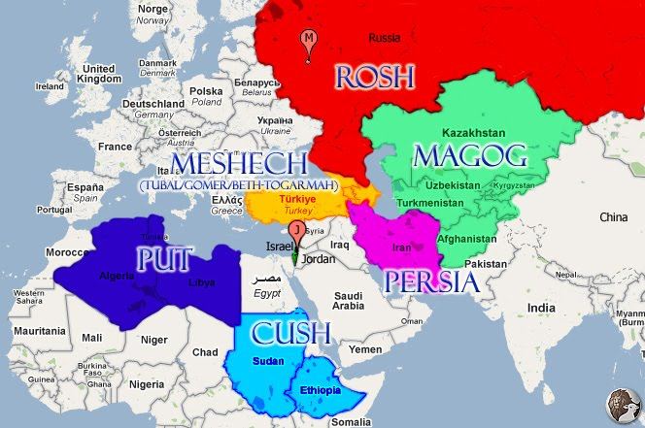

**(v8-12) Notice in verse 8 we have the timetable in the *“latter days;”*** then in **verse 9** observe the verbiage ***“like a storm, a cloud all your troops and many peoples with you.”*** Could this be the Muslim ***“Jihad”*** – **HOLY WAR**! (Look at the Muslim nations on the map that surrounds Israel.) In verse 10 we discover the middle east peace plan has become an ***evil plan in the minds*** of those surrounding nations. Verse 11 and 12 speaks of their invasion of Israel, verse 12 talks about a land that is once again inhabited, a people gathered from the nations.

**(v13) On the sidelines: *"Sheba, and Dedan, and the merchants of Tarshish, with all the young lions thereof, shall say unto thee, Art thou come to take a spoil? Hast thou gathered thy company to take a prey, to carry away silver and gold, to take away cattle and goods, to take a great spoil? "*** [**Ezekiel 38:13**](http://www.blueletterbible.org/kjv/Eze/Eze038.html#13)

**(Many Bible scholars believe that America is part of the “young lions.”)**

**- SHEBA and DEDAN were cities in what are now Saudi Arabia. It is interesting that they are *not* involved in the invasion ... but rather sitting on the sidelines watching it unfold (protecting their oil).**

**- TARSHISH ... "The name of a place which first comes into notice in the days of Solomon. The question as to the locality of Tarshish has given rise to not a little discussion. Some think there was a Tarshish in the East, on the Indian coast, seeing that "ships of Tarshish" sailed from Eziongeber, on the Red Sea (1 Kings 9:26; 22:48; 2 Chr. 9:21). Some, again, argue that Carthage was the place so named. There can be little doubt, however, that this is the name of a Phoenician port in Spain, between the two mouths of the Guadalquivir (the name given to the river by the Arabs and meaning "the great wady" or watercourse). It was founded by a Carthaginian and was the farthest western harbor of Tyrian sailors. It was to this port Jonah's ship was about to sail from Joppa. It has well been styled "the Peru of Tyrian adventure;" it abounded in gold and silver mines."**

**> What about *Syria*? - As described in Isaiah chapter 17, Jeremiah 49:23-27 and elsewhere ... *"The burden of Damascus. Behold, Damascus is taken away from being a city, and it shall be a ruinous heap.... And behold at eveningtide trouble; and before the morning he is not. This is the portion of them that spoil us, and the lot of them that rob us."*** [***Isaiah 17:1,14***](http://www.blueletterbible.org/kjv/Isa/Isa017.html#top)

***"Damascus is waxed feeble, and turneth herself to flee, and fear hath seized on her: anguish and sorrows have taken her, as a woman in travail. How is the city of praise not left, the city of my joy!"*** [***Jeremiah 49:24-25***](http://www.blueletterbible.org/kjv/Jer/Jer049.html#23)

**Damascus, the capital of Syria, is known to be the oldest continuously inhabited city in the world! ... It has never yet been "taken away from being a city."**

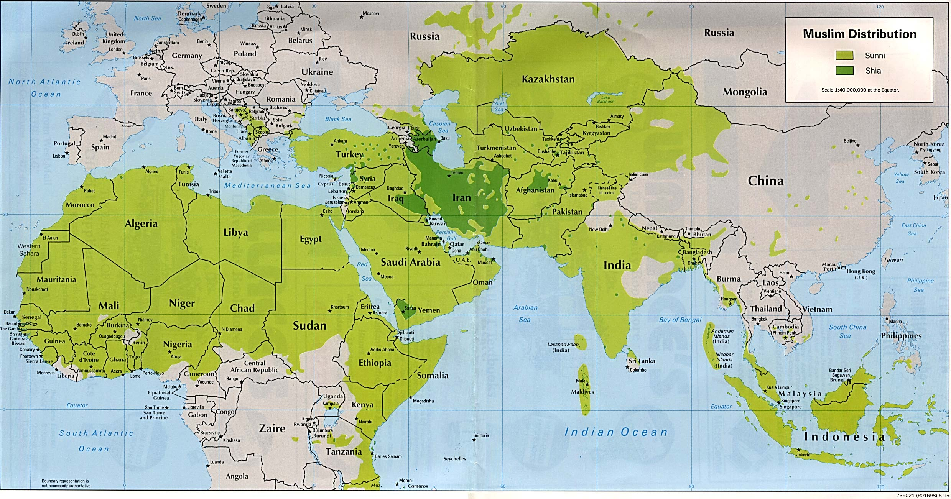

**> Insight on ISLAM -** In his book, ***Secrets of the Koran****,* Don Richardson asks some probing questions about this, writing: “If Islam is a peaceful religion, then why did Mohammed engage in 47 battles? Why, in every campaign the Muslim armies have fought throughout history, have they slaughtered men, women and children who did not bow their knees to the lordship of Islam? . . . If Islam is so peaceful, why are there so many verses in the Koran about killing the infidels and those who resist Islam? If Islam is peaceful, why isn’t there even one Muslim country that will allow freedom of religion and speech? Not one! If Islam is peaceful, who is imparting this awful violence to hundreds of Islamic groups throughout the world who kill innocent people in the name of Allah?”

- [Bill Warner interview](http://archive.frontpagemag.com/readArticle.aspx?ARTID=297), Feb 2007 (and [copy](http://www.politicalislam.com/blog/the-study-of-political-islam-2/)) - "First, let's see how ignorant we are about the history of political Islam. How many Christians can tell you how [Turkey](http://en.wikipedia.org/wiki/Fall_of_Constantinople) or [Egypt](http://en.wikipedia.org/wiki/Muslim_conquest_of_Egypt) became Islamic? What happened to the [Seven Churches of Asia](http://en.wikipedia.org/wiki/Seven_churches_of_Asia) mentioned in Paul's letters? Find a Jew who can tell you the Jewish history of [dhimmitude](http://en.wikipedia.org/wiki/Dhimmi) (second class citizens who serve Islam). What European knows that white women were the highest priced [slaves](http://markhumphrys.com/islam.killings.html#slavery) in Mecca? Everyone knows how many Jews Hitler killed, but find an unbeliever who can tell you how many died in jihad over the last 1400 years. . . Jihad destroyed a [Christian Middle East](http://en.wikipedia.org/wiki/Byzantine-Arab_Wars) and a [Christian North Africa](http://en.wikipedia.org/wiki/Umayyad_conquest_of_North_Africa). Soon it was the fate of the [Persian Zoroastrian](http://en.wikipedia.org/wiki/Islamic_conquest_of_Persia) and the [Hindu](http://en.wikipedia.org/wiki/Muslim_conquest_in_the_Indian_subcontinent) to be the victims of jihad. The history of political Islam is the destruction of Christianity in the Middle East, Egypt, Turkey and North Africa. **Half of Christianity was lost**. Before Islam, North Africa was the southern part of Europe (part of the Roman Empire). **Around 60 million Christians were slaughtered** during the jihadic conquest. Half of the glorious Hindu civilization was annihilated, and **80 million Hindus killed**. The first Western [Buddhists](http://en.wikipedia.org/wiki/Islamic_conquest_of_Afghanistan) were the Greeks descended from Alexander the Great's army in what is now Afghanistan. Jihad destroyed all of Buddhism along the silk route. **About 10 million Buddhists died**. The conquest of Buddhism is the practical result of pacifism. [Zoroastrianism](http://en.wikipedia.org/wiki/Zoroastrianism) was eliminated from Persia. The Jews became permanent dhimmis throughout Islam. **In Africa over 120 million Christians and animists have died** over the last 1400 years of jihad. **Approximately 270 million nonbelievers died** over the last 1400 years for the glory of political Islam. These are the Tears of Jihad which are not taught in any school."

**(v14-17) Once again the *latter days* is mentioned (v16); when the invasion takes place God says, *“It will be in the latter days that I will bring you against MY LAND, so that the nations may KNOW ME, when I am HALLOWED in you, O Gog, before their eyes.”***

**(Also, Zechariah 12:1-9)**

**(v18-19) God brings forth a great earthquake. (Insight: Major earthquakes have been recorded in Syria and the Middle East for hundreds of years. In AD 454 and 555, major quakes destroyed Latakia, and in 847 a devastating quake hit Damascus and the surrounding area. The country’s worst recorded earthquake in 1138 hit Allepo killing an estimated 230,000 people. Syria’s latest recorded quake hit Allepo in 1822 killing 20,000 and thousands more homeless.) (EARTHQUAKES IN REVELATION - Rev 6:12–17; 11:19; 16:17–21; 19:11–21)**

**> This is a list of active and extinct** [**volcanoes**](http://en.wikipedia.org/wiki/Volcano) **in** [**Syria**](http://en.wikipedia.org/wiki/Syria)**.**

|  |  |  |  |  |
| --- | --- | --- | --- | --- |
| Name | Elevation | | Location | Last eruption |
| meters | feet | [Coordinates](http://en.wikipedia.org/wiki/Geographic_coordinates) |
| [Al-Safa](http://en.wikipedia.org/wiki/Al-Safa_(Syria)) | 979 | 3212 | http://upload.wikimedia.org/wikipedia/commons/thumb/5/55/WMA_button2b.png/17px-WMA_button2b.png[33°02′N 37°12′E﻿ / ﻿33.03°N 37.2°E﻿ / 33.03; 37.2](http://tools.wmflabs.org/geohack/geohack.php?pagename=List_of_volcanoes_in_Syria&params=33.03_N_37.2_E_type:mountain) | 1850 AD ± 10 yrs. |
| [Golan Heights](http://en.wikipedia.org/wiki/Golan_Heights) | 1197 | 3927 | http://upload.wikimedia.org/wikipedia/commons/thumb/5/55/WMA_button2b.png/17px-WMA_button2b.png[33°N 36°E﻿ / ﻿33°N 36°E﻿ / 33; 36](http://tools.wmflabs.org/geohack/geohack.php?pagename=List_of_volcanoes_in_Syria&params=33_N_36_E_type:mountain) | Holocene |
| [Jabal ad Druze](http://en.wikipedia.org/wiki/Jabal_ad_Druze) | 1803 | 5915 | http://upload.wikimedia.org/wikipedia/commons/thumb/5/55/WMA_button2b.png/17px-WMA_button2b.png[32°42′N 36°42′E﻿ / ﻿32.7°N 36.7°E﻿ / 32.7; 36.7](http://tools.wmflabs.org/geohack/geohack.php?pagename=List_of_volcanoes_in_Syria&params=32.7_N_36.7_E_type:mountain) | Holocene |
| [Sharat Kovakab](http://en.wikipedia.org/wiki/Sharat_Kovakab) | 534 | 1752 | http://upload.wikimedia.org/wikipedia/commons/thumb/5/55/WMA_button2b.png/17px-WMA_button2b.png[36°32′N 40°52′E﻿ / ﻿36.54°N 40.86°E﻿ / 36.54; 40.86](http://tools.wmflabs.org/geohack/geohack.php?pagename=List_of_volcanoes_in_Syria&params=36.54_N_40.86_E_type:mountain) | Holocene |
| Jabal Abu-Rgheile [[1]](http://en.wikipedia.org/wiki/List_of_volcanoes_in_Syria#cite_note-1) | 945 | 3100 | http://upload.wikimedia.org/wikipedia/commons/thumb/5/55/WMA_button2b.png/17px-WMA_button2b.png[33°00′N 36°30′E﻿ / ﻿33°N 36.5°E﻿ / 33; 36.5](http://tools.wmflabs.org/geohack/geohack.php?pagename=List_of_volcanoes_in_Syria&params=33_N_36.5_E_type:mountain) | 2670 BC ± 200 years |
| Unnamed | N/A | N/A | Near [Kilis](http://en.wikipedia.org/wiki/Kilis), Turkey, which is at http://upload.wikimedia.org/wikipedia/commons/thumb/5/55/WMA_button2b.png/17px-WMA_button2b.png[36°42′N 37°06′E﻿ / ﻿36.7°N 37.1°](http://tools.wmflabs.org/geohack/geohack.php?pagename=List_of_volcanoes_in_Syria&params=36.7_N_37.1_E_) |  |

**(v20-23) God brings confusion, calamity, and catastrophe upon these invading enemies of Israel.**

> EZEKIEL CHAPTER 39 - *“JIHAD!”*

**(v1-6) God continues to speak through Ezekiel prophesying the destruction of Gog and the other invaders.**

**(v7-8) Two keys: (1) God will make *His HOLY name known in the midst of MY PEOPLE ISRAEL, and He will not let them PROFANE HIS HOLY NAME ANYMORE* (2) Then the *NATIONS shall KNOW the LORD is the HOLY ONE IN ISRAEL.***

**(v9-10) Take notice that the weapons of the enemies of Israel will be burned for seven years without wood.**

**(v11-16) It will take “SEVEN MONTHS” to bury the bodies of the enemy as a special SEARCH PARTY will mark the bones and another group of special buriers will bury the remains.**

**(v17-20) Bring on the birds for a great feast!**

**(v21-24) God will re-establish His relationship with Israel and He explains why they were forsaken for so long.**

**(v25-29) This speaks of God’s restoration of Israel and their conversion.**

**> What about America?**

**America could be destroyed, but more likely America will union with the globalist cabal of the last days, the one world government lead by the Antichrist (Psalm 2; 2 Thessalonians Ch. 2; Revelation chapters 6 - 19). The Bible speaks of the last days generation, and how true Christians are to live in 2 Timothy Chapters 3 – 4.**

**- Today all “born again” Christians must fulfill the “GREAT COMMISSION!”**

**Jesus said in Matthew 28:18-20 - *"All authority has been given to Me in heaven and on earth. Go therefore and make disciples of all the nations, baptizing them in the name of the Father and of the Son and of the Holy Spirit, teaching them to observe all things that I have commanded you; and lo, I am with you always, even to the end of the age." Amen.***

**- Let us be the “Church of Philadephia” in Revelation Chapter 3:7-13; always keeping the Word of God from Genesis to Revelation, and never denying His name, the name of our Lord and Savior JESUS CHRIST!**

**- Jesus has promise all born again believers in Revelation 3:10-11 *- Because you have kept My command to persevere, I also will keep you from the hour of trial which shall come upon the whole world, to test those who dwell on the earth. 11 Behold, I am coming quickly! Hold fast what you have, that no one may take your crown.***

***LET’S “GO 4 GOD!”***